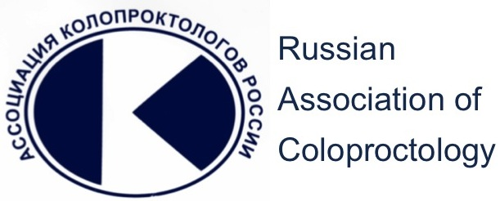

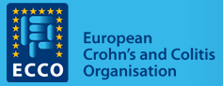

International Joint Congress of Russian Association of Сoloproctology and 1st ESCP/ECCO joint regional Masterclass

Moscow 16-18 April 2015 www.ijcc-russia.ru

Dear Colleagues,

I am delighted to announce that the International Joint Congress of Russian Association of coloproctology and 1st European Society of Coloproctology (ESCP) and European Crohn’s and Colitis Organisation (ECCO) regional Masterclass will be held in Moscow, Russia on April 16-18, 2015.
Russian Association of coloproctology was established in 1992 and currently it numbers more than 800 members from all regions of Russia and abroad. The last All-Russia Congress of the Association was successfully held in Belgorod 2011 and brought together more than a thousand attendees. The remarkable thing is that in the 2015 is the year of 50th Anniversary of the State Scientific Centre of coloproctology, which is the institution completely devoted to the treatment and investigation of colorectal disease.
The forthcoming congress will have a new format of International event. The programme of conference includes the key note lectures of Russian and international experts in colorectal surgery, gastroenterology and medical imaging. European Society of coloproctology as well as European Crohn’s and Colitis Organisation gave the great contribution into scientific programme. Together with them, we established a stimulating special consideration to the importance of multidisciplinary treatment of IBD. The 1st ESCP/ECCO joint regional Master class on the first day of the Congress promises the great interest of trainees, doctors and researchers from every part of Russia. We expect an exchange of the scientific ideas and hope that our Congress allows to set‐up a new contacts and cooperative studies.
Besides these scientific and educational tasks, the social programme provides opportunities for making new friends and deepens existing friendships and, of course, simply became acquainted with the capital of Russia, the city with reach history and cultural highlights.

I look forward to seeing you in Moscow in April 2015 and on behalf of the three societies, I extend a warm welcome to you all!
Yours sincerely,

Prof. Yury Shelygin
Incoming Congress President
President of Russian Association of Coloproctology
President Elect of European Society of coloproctology

Organizing Committee
Sergey Achkasov (Russia)
Donato Altomare (Italy)
Najib Haboubi (UK)
Zoran Krivokapic (Serbia)
Ronan O’Connell (Ireland)
Evgeny Rybakov (Russia)
Yuri Shelygin (Russia)

Invited Speakers
Donato Altomare (Italy)
Regina Beets-Tan (Netherlands)
Paulo Kotze (Brazil)
Sue Clark (UK)
André D’Hoore (Belgium)
Igor Khalif (Russia)
Eloy Espin-Basany (Spain)
Sergey Koncevoi (USA)
Zoran Krivokapic (Serbia)
Klaus Matzel (Germany)
Ronan O’Connell (Ireland)
Sarah O’Dwyer (UK)
Mike Parker (UK)
Yves Panis (France)
Stefan Post (Germany)
Jordi Rimola (Spain)
Tomas Scricka (Czech Republic)
Marek Szczepkowski (Poland)
Peter Dawson (UK)
Dion Morton (UK)
Per Nilsson (Sweden)
Alex Kartheuser (Belgium)
Giovanni Romano (Italy)
Karen Telford (UK)
Ailsa Hart (UK)
Goran Barisic (Serbia)

Key dates
November 1, 2014
Registration for the International Joint Congress of Russian Association of coloproctology and 1st ESCP/ECCO joint regional Masterclass is open on
www.ijcc-russia.com

March 1, 2015
Final program

Congress venue
RENAISSANCE MOSCOW MONARCH CENTRE HOTEL
31A Leningradsky Prospect Bldg.1 Moscow Russia
t: 7 495 995 00 09
reservations@renaissancemcmoscow.ru
renaissancemonarchmoscow.com
Congress language
The official languages of the congress are Russian and English. Simultaneous Russian/English interpretation will be provided.
Certificate of Attendance
All registered delegates can download and print their certificate of attendance in their individual user area in the online registration system after the congress

